In the past two weeks, my main focus is still on search query feature construction and trending detection.

In last biweekly report I mentioned I have finished shortlisting query features, and to handover to data engineer colleague who will help to build these features in a more systemic way, I need to prepare documents specifically describing the logics and requirements. Meanwhile, to make sure they can understand the thing we need, I also need to prepare a sample SQL query to 1. Make sure their outcome has same logic as we expected and 2. Simplify their workload. After I finished preparing sample SQL queries, I also prepared a proposed workflow for DE colleague to refer to.

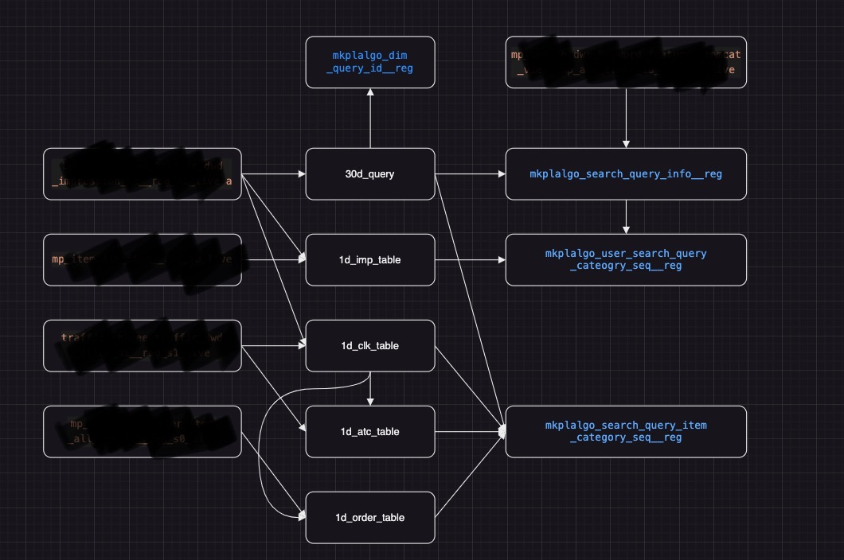

The blurred ones are the current existing table in Shopee database, the white ones are intermediate table I created for a clearer logic flow and finally the blue ones are the output table.

The second thing I did in the last two weeks is about trending detected. Previously we have developed a rather simple algorithm that calculates a weighted score using view_count, click_count and order_count to detect trending. But that ignores much information like the natural distribution of data. Therefore, in the improved algorithm, I assume the data follows a poisson distribution. And I consider a data is trending if it exceeds the confidence interval calculated using previous data certain times. By testing, with improved algorithm, there are two main effects: 1. Improved trending accuracy. 2. Higher user/order cover under similar amount of trendings.